COUNCIL ASSESSMENT REPORT
Panel Reference | PPSHCC-124
DA Number | DA2021/2110
LGA | MidCoast Council
Proposed Development | Refurbishment and expansion of an existing basketball court building;  - Addition of new basketball courts at rear of existing building, including an additional three (3) basketball courts;  - Addition of new ancillary components including spectator seating, change rooms, storage rooms, first aid rooms, café space, patron toilets, reception and foyer, and office space;  - Addition of mezzanine area for multipurpose use with kitchen and lift facility; and  - Addition of new outdoor decking and pedestrian pathways.
Street Address | Lot 1 DP 798539  Lot 2 DP 798539  Lot 1 DP 783990  Manning River Drive Taree
Applicant/Owner | Greater Taree City Council (MidCoast Council)
Date of DA lodgement | 11 November 2021
Total number of Submissions  Number of Unique Objections | Nil
Recommendation | Approval
Regional Development Criteria (Schedule 7 of the SEPP (State and Regional Development) 2011 | Pursuant to Schedule 6 of State Environmental Planning Policy (Planning Systems) 2021 the proposal is Council related development over $5 million, as MidCoast Council is the owner of the land on which the development is to be carried out.
List of all relevant s4.15(1)(a) matters | - Environmental Planning and Assessment Act 1979  - Environmental Planning and Assessment Regulation 2021  - State Environmental Planning Policy (Planning Systems) 2021  - State Environmental Planning Policy (Resilience and Hazards) 2021  - State Environmental Planning Policy (Transport and Infrastructure) 2021  - State Environmental Planning Policy (Industry and Employment) 2021  - Greater Taree Local Environmental Plan 2010  - Greater Taree Development Control Plan 2010  - Greater Taree s94A (S7.12) Contributions Plan 2016

List all documents submitted with this report for the Panel’s consideration | Attachment A – Architectural Plans  Attachment B – Statement of Environmental Effects  Attachment C - Waste Management Plan  Attachment D - Crime Risk Assessment  Attachment E - Civil Plans  Attachment F - Flood Certificate  Attachment G - QS Report  Attachment H – Traffic Impact Assessment  Attachment I – Stormwater Management Plan  Attachment J – Emergency Business Plan  Attachment K – Site Operational Plan  Attachment L – Bike Club Letter  Attachment M – Conditions of Consent
Clause 4.6 requests | Nil
Summary of key submissions | N/A
Report prepared by | Bruce Moore, Coordinator Major Assessment MidCoast Council
Report date | 21 June 2022
Summary of s4.15 matters  Have all recommendations in relation to relevant s4.15 matters been summarised in the Executive Summary of the assessment report? |  | Yes
Legislative clauses requiring consent authority satisfaction  Have relevant clauses in all applicable environmental planning instruments where the consent authority must be satisfied about a particular matter been listed, and relevant recommendations summarized, in the Executive Summary of the assessment report?  e.g. Clause 7 of SEPP 55 - Remediation of Land, Clause 4.6(4) of the relevant LEP |  | Yes
Clause 4.6 Exceptions to development standards  If a written request for a contravention to a development standard (clause 4.6 of the LEP) has been received, has it been attached to the assessment report? |  | Not applicable
Special Infrastructure Contributions  Does the DA require Special Infrastructure Contributions conditions (S7.24)?  Note: Certain DAs in the Western Sydney Growth Areas Special Contributions Area may require specific Special Infrastructure Contributions (SIC) conditions |  | No
Conditions  Have draft conditions been provided to the applicant for comment?  Note: in order to reduce delays in determinations, the Panel prefer that draft conditions, notwithstanding Council’s recommendation, be provided to the applicant to enable any comments to be considered as part of the assessment report |  | Yes

EXECUTIVE SUMMARY
Consent is sought for the refurbishment and expansion of an existing basketball facility and associated works, at Lot 1 DP 798539, Lot 2 DP 798539 and Lot 1 DP 783990 Manning River Drive Taree.
The land supports a variety of recreational activities and is known as the Taree Regional Recreational Centre.
The application is referred to the Hunter and Central Coast Regional Planning Panel as the application is Council related development over $5 million, with MidCoast Council being the owner of the land on which the development is to be carried out.
Two briefings have been held with the Hunter and Central Coast Regional Planning Panel.
The application was exhibited from 17 February 2022 to 4 April 2022 with no submissions being received.
The application was referred to Essential Energy and Transport for NSW for comment.
The development is not identified as integrated development and there were no concurrence requirements from agencies for the proposal.
The development has been assessed to be compliant with applicable State, Regional, and Local Environmental Planning Instruments and Policies, including:
- Environmental Planning and Assessment Act 1979
- Environmental Planning and Assessment Regulation 2021
- State Environmental Planning Policy (Planning Systems) 2021
- State Environmental Planning Policy (Resilience and Hazards) 2021
- State Environmental Planning Policy (Transport and Infrastructure) 2021
- State Environmental Planning Policy (Industry and Employment) 2021
- Greater Taree Local Environmental Plan 2010
- Greater Taree Development Control Plan 2010
The proposal is consistent with the various provisions of the planning controls including:
- The development is consistent with the relevant zone objectives.
- The development achieves appropriate built form outcomes.
- Traffic impact associated with the development is acceptable, noting measures have been proposed to address peak impacts and impacts associated with events.
- The development does not adversely impact any ecological features/attributes of the site, including flora and fauna.
It is recommended that the Panel determine Development Application 2021/2110 for the refurbishment and expansion of an existing basketball facility, at Lot 1 DP 798539, Lot 2 DP 798539 and Lot 1 DP 783990 Manning River Drive Taree, pursuant to Section 4.16 of the Environmental Planning & Assessment Act 1979, by granting consent, subject to the conditions contained in this report at Attachment M.

- THE SITE AND LOCALITY

The subject site is located at the eastern extremity of Taree and is legally described as Lot 1 & 2 DP798539 and Lot 1 DP783990. The lot is irregular in shape and covers an area of approximately 51ha.
The northern boundary of the site is formed by the Dawson River. The southern boundary has frontage to Manning River Drive, with the Manning River located approximately 100m further to the south. The northern part of the site supports significant tracts of vegetation, while the remainder of the land is mostly cleared.
Access to the site is available from Recreation Lane (to the west), Manning River Drive (to the south) and Keith Coleman Drive / Centenarians Way (to the east).
A broad range of land uses adjoin the site including but not limited to residential properties, nursing home, car sales yard, and commercial premises.

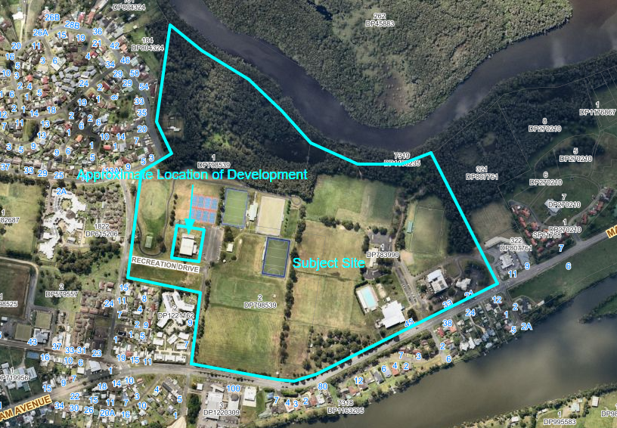
Figure 1 – Site Aerial (Source Intrampas)

The site is known as the ‘Taree Regional Recreation Centre’ and includes basketball courts, netball courts, hockey fields, soccer fields, criterium track, general sports fields, aquatic centre, entertainment centre, information centre and car parking. These facilities have been located in the ‘cleared’ part of the site.
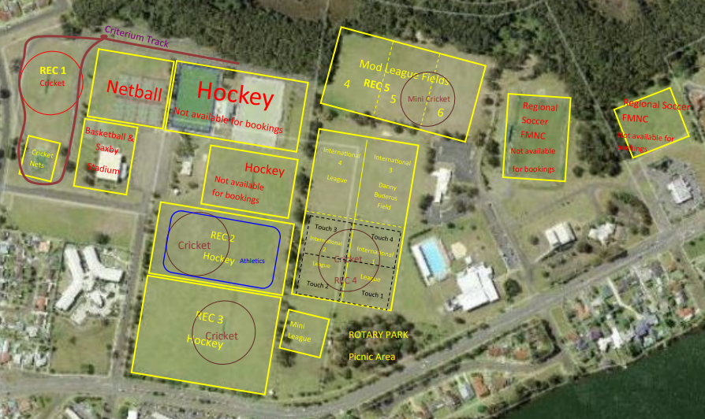
Figure 2 – Recreational Uses Map (Source MidCoast Council)
The development area is located within Lot 1 D798539 with frontage to Recreation Drive. The development area currently contains the existing basketball facility and part of the criterium track.
The development area is relatively level. Several scattered trees are located to the west and south of the existing basketball facility.
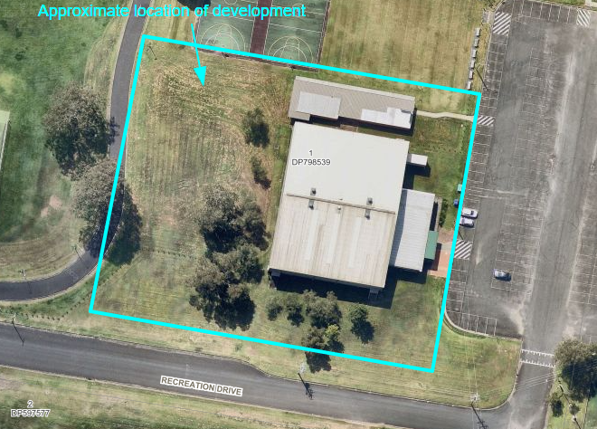
Figure 3 - Site Aerial Development Area (Source: Intra Maps)
- THE PROPOSAL AND BACKGROUND
  - The proposal
The application seeks consent for the refurbishment and expansion to an existing basketball facility. Specifically, the proposed development includes:

- Refurbishment of existing basketball court building;
- Addition of new basketball courts at rear of existing building, including an additional three (3) basketball courts;
- Addition of new ancillary components including spectator seating, change rooms, storage rooms, first aid rooms, café space, patron toilets, reception and foyer, and office space;
- Addition of mezzanine area for multipurpose use with kitchen and lift facility;
- Addition of new outdoor decking and pedestrian pathways;
- Removal of several trees; and
- Minor adjustment to the existing criterium track.

The development will provide improved facilities for visitors, athletes, and staff as well as enable regional events to take place in a more efficient and improved manner and funding from the Bushfire Local Economic Recovery Fund has been granted to TBA for the design and expansion of the existing Taree Basketball Stadium (Saxby’s Stadium).

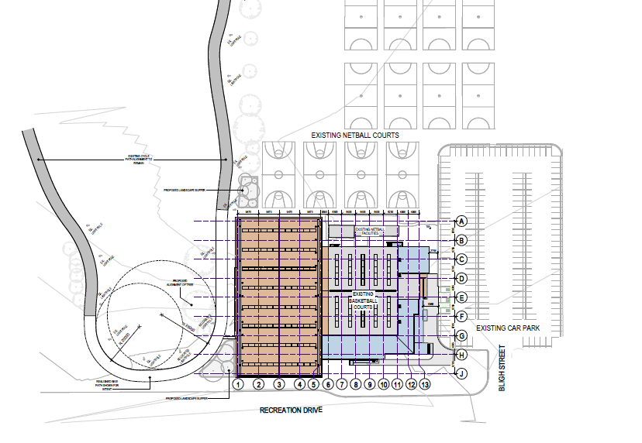
Figure 4 – Site Plan Development Area (Source: HSPC)

The development is proposed to be constructed in two stages.
Stage One will comprise of the following works:
- Refurbishment of existing basketball court building;
- Addition of new basketball courts at rear of existing building including an additional three (3) basketball courts, with space to store future retractable seats;
- Additional of Gallery 1 proving access to the new rear courts;
- Addition of part of the new outdoor decking and pedestrian ramp 1; and
- Signage.

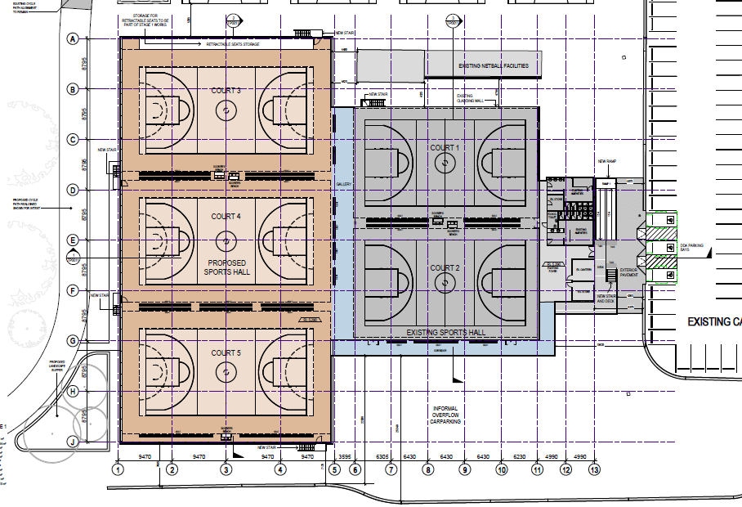
Figure 5 – Stage 1 Floor Plan (Source: HSPC)

Stage Two will comprise the following works:
- Addition of new ancillary components including spectator seating, change rooms, storage rooms, first aid rooms, café space, patron toilets, reception and foyer, and office space;
- Addition of mezzanine area for multipurpose use with kitchen and lift facility;
- Addition of new outdoor decking and pedestrian pathways; and
- Installation of retractable seating.

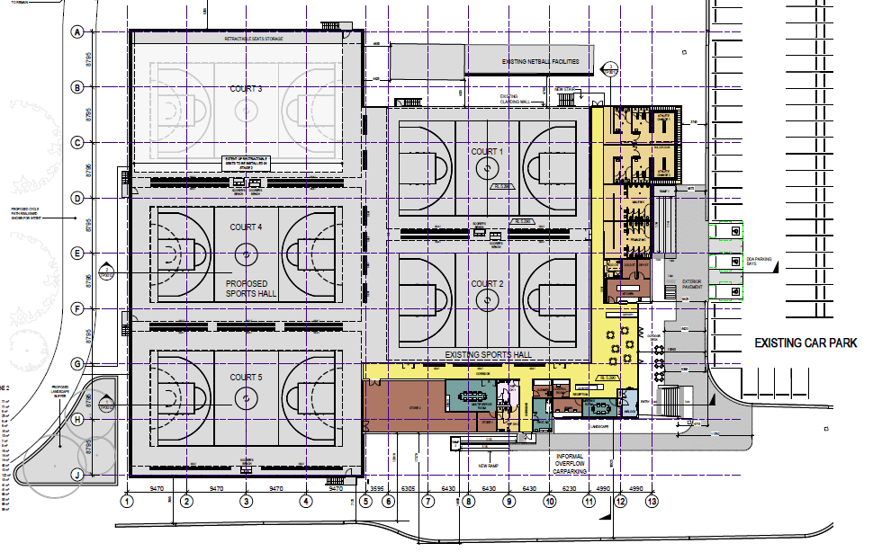
Figure 6 – Stage 2 Floor Plan (Source HSPC)

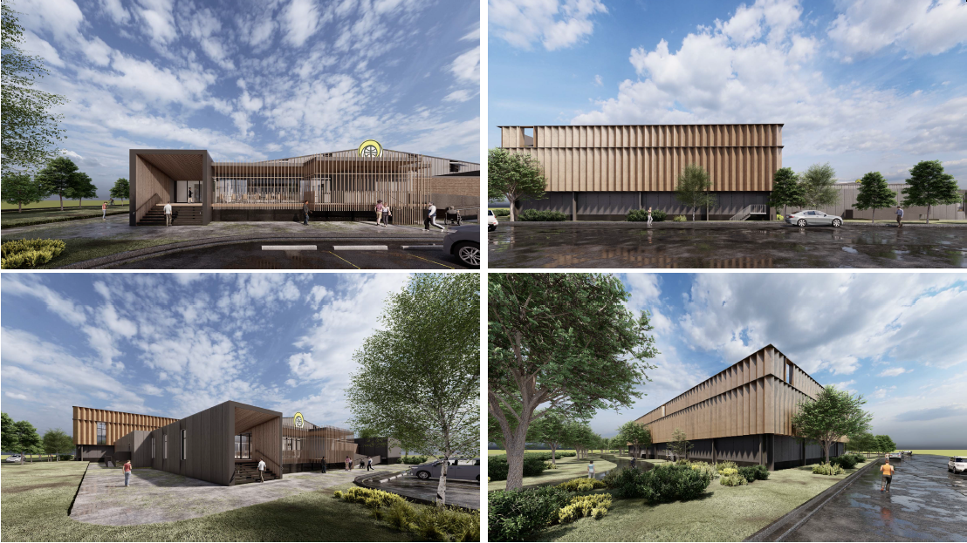
Figure 7 – Perspectives (Source: HSPC)

  - Background
On 31 March 2022 a kick-off briefing was held with the Hunter & Central Coast Regional Planning Panel (RPP).
The following key issues were identified for consideration:
- Stormwater and water quality to be considered in the assessment report, with above ground solutions to be documented and included in amended site and elevation plans
- Flooding – detailed flood evacuation plan required, which identifies the available warning time and flood velocity
- Adequacy of parking arrangements and potential for off-site impacts
- Detailed Site Operational Management Plan for Regional Sporting Facility to be provided that is supported by a detailed analysis and confirms how all facilities will operate, provision of adequate parking, frequency of requirement for overflow parking and impact assessment on local traffic network
- Timing of future support facilities and confirmation that the proposed development can operate without these facilities
In response the applicant provided additional information to address the issues raised by the JRPP. This information is considered in assessment of the application.

- STATUTORY CONSIDERATIONS
  - Section 4.14 Consultation and development consent—certain bush fire prone land
The northern part of the site is mapped as ‘bushfire prone land, as shown in figure 8.
The area of the proposed development is not within areas mapped as bushfire prone land or a buffer area.
Notwithstanding the development is well separated from vegetated areas, provided with a suitable defendable space and has suitable access that is not reliant on bushfire prone land.
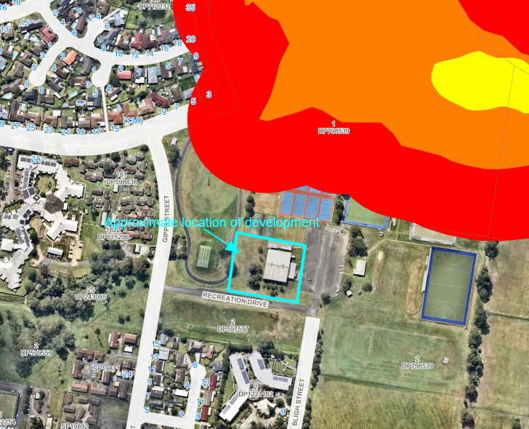
Figure 8 – Bushfire prone Land (Source: Intramaps)

  - Section 4.15(1)(a)(i) - Provisions of Environmental Planning Instruments
The following Environmental Planning Instruments are relevant to this application:
- State Environmental Planning Policy (Planning Systems) 2021
- State Environmental Planning Policy (Resilience and Hazards) 2021
- State Environmental Planning Policy (Transport and Infrastructure) 2021
- Greater Taree Local Environmental Plan 2010

State Environmental Planning Policy (Planning Systems) 2021
The application is regionally significant development under Part 2.4 Regionally significant development and Schedule 6 – clause 3 of the SEPP as MidCoast Council owns the land and the capital investment value of the development exceeds $5 million.
Accordingly, the Hunter and Central Coast Regional Planning Panel is the consent authority for the application.

State Environmental Planning Policy (Resilience and Hazards) 2021
Division 3 Coastal environment area
The site is mapped as being within the ‘coastal environment area’ and Division 3 State Environmental Planning Policy (Resilience and Hazards) 2021 is applicable to the proposed development.
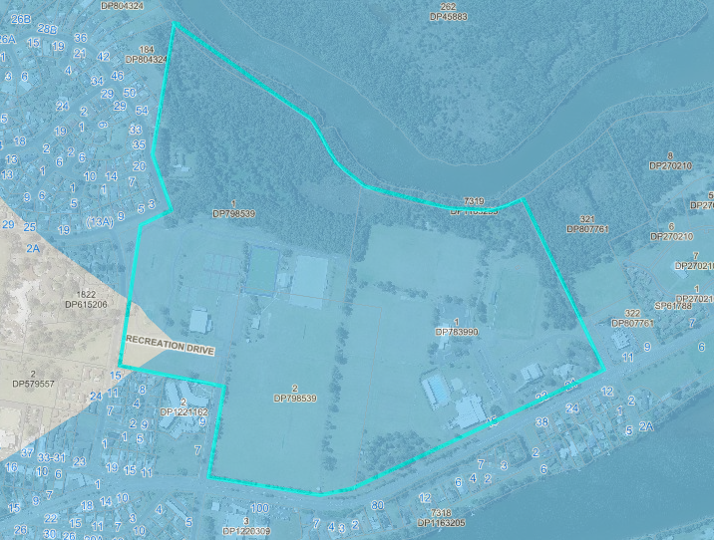
Figure 9 – Coastal Environment Area (Source: Intramaps)

Table 1 below lists the matters for consideration prescribed by Section 2.10(1) of the SEPP and details how they relate to the proposed development.

SEPP (Resilience and Hazards) 2021
Table 1: Section 2.10(1) Considerations
Section 2.10 (1) | Comment
(a) the integrity and resilience of the biophysical, hydrological (surface and groundwater) and ecological environment, | The development will have no adverse impact on the integrity and resilience of the biophysical, hydrological (surface and groundwater) and ecological environment
(b) coastal environmental values and natural coastal processes, | The development will have no impact on coastal environmental values and natural coastal processes

(c) the water quality of the marine estate (within the meaning of the Marine Estate Management Act 2014), in particular, the cumulative impacts of the proposed development on any of the sensitive coastal lakes identified in Schedule 1, | The development will have no impact on a marine estate or sensitive coastal lake.
(d) marine vegetation, native vegetation and fauna and their habitats, undeveloped headlands and rock platforms, | The proposed development will have no adverse impact on marine vegetation, native vegetation or fauna.
(e) existing public open space and safe access to and along the foreshore, beach, headland or rock platform for members of the public, including persons with a disability, | No impacts on the existing, safe access to and along the foreshore, beach, headland or rock platform for members of the public, including persons with a disability is likely to result from the development.
(f) Aboriginal cultural heritage, practices and places, | The proposal will have no adverse impact on aboriginal cultural heritage, practices or places. An AHIMS search was conducted and revealed no sites within proximity to the development.
(g) the use of the surf zone. | The development will have no adverse impact on the surf zone.

Chapter 4 Remediation of land
Under section 4.6 of the SEPP, a consent authority must not consent to the carrying out of any development on land unless it has considered whether the land is contaminated, and if the land is contaminated, it is satisfied the land is suitable in its contaminated state (or will be suitable after remediation) for the purpose for which the development is proposed to be carried out.
The site has historically been utilised for recreational purposes with the proposed development including the continuation of a recreational land use. No potentially contaminating activity is known to have occurred on or in the vicinity of the development site.

As the development does not propose any change in use and given that there is no history of any potential contamination, the land is considered to be suitable for the purpose of a recreational facility.

State Environmental Planning Policy (Transport and Infrastructure) 2021
2.48 Determination of development applications—other development
The application was referred to Essential Energy under clause 2.48 of the SEPP. In response Essential Energy requested further information from the applicant.
The request is detailed below:
Essential Energy notes that existing overhead powerlines (11kV street frontage and LV) are impacted by the proposed development and it has safety concerns in relation to the proximity of the proposed development to its powerlines.

Please have the Applicant provide a revised site plan showing:

- The location of the proposed expansion including all elevations and height from the top of the proposed new structure to all nearest conductor/s (powerline/s) and all nearest power pole/s.
- The location of the proposed expansion and the distance (horizontal) to all nearest conductor/s (powerline/s) and all nearest power pole/s.

In response the applicant advised of the following:
Electricity infrastructure including powerlines and poles are detailed on the Civil Plan set, on page 5 or sheet DA-C03.01.

The structure proposed is considered non-climbable and therefore requires a minimum clearance of 1.5 metres horizontally from the nearest high voltage conductor and a minimum clearance of 0.6 metres from the nearest low voltage conductor measured from the conductor’s maximum blowout position.

The powerlines on the Recreation Drive frontage are located 7 metres from the nearest part of the proposed, refer to Figure 1 below. A blowout would need to be 5.5 metres in order to encroach on the minimum clearance of 1.5 metres. A blowout is not expected to this extent and therefore the proposed complies.

The low voltage powerlines which are currently located across the front of the building have an estimated maximum blow out of around 1.5-1.8 metres. These powerlines are located 2.5 metres from the nearest part of the proposed, refer to Figure 2 below, and therefore achieves the required minimum clearance of 0.6 metres.

Figure 1 Extract of Civil Plans showing powerline proximity along Recreation Drive (not to scale)
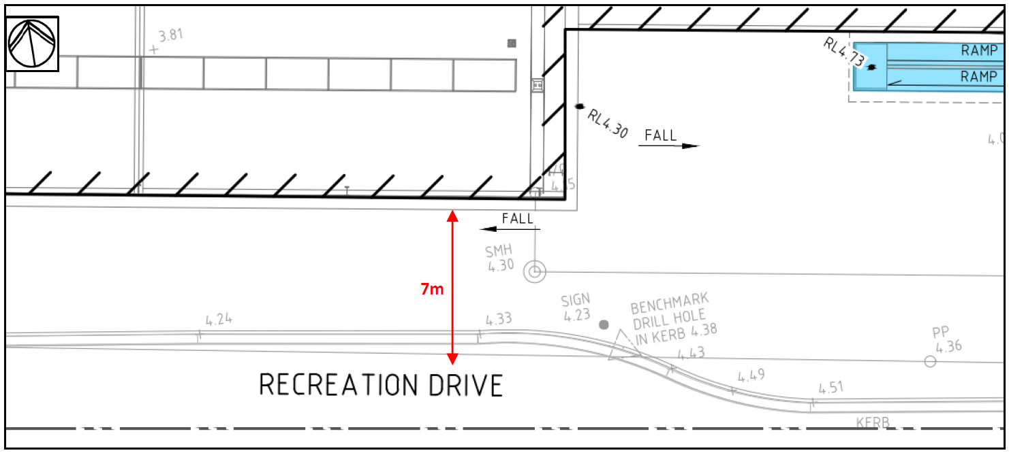

Figure 2 Extract of Civil Plans showing powerline proximity along proposed front of building (not to scale)
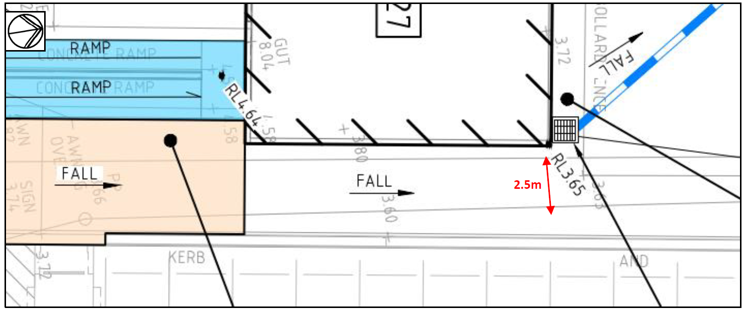

Section 2.48(2) of the SEPP provides that ‘before determining a development application (or an application for modification of a consent) for development to which this section applies, the consent authority must—
- give written notice to the electricity supply authority for the area in which the development is to be carried out, inviting comments about potential safety risks, and
- take into consideration any response to the notice that is received within 21 days after the notice is given.’
The additional information was forwarded to Essential Energy on 30 March 2022. At the time of writing this report, more than 21 days had passed, and no further response had been received from Essential Energy.
Notwithstanding, the development is considered to be compliant with the requirements of Essential Energy.

2.121 Traffic-generating development
The application was referred to Transport for NSW (TfNSW) under clause 2.121 as larger events accommodated by the proposed development may be considered to be ‘traffic generating development’, in that some events may result in more than 200 or more motor vehicles per hour.
In response, TfNS advised:
‘Manning River Drive is an unclassified regional road. Council is the roads authority for this road and all other public roads in the area, in accordance with Section 7 of the Roads Act 1993.
TfNSW has reviewed the referred information and advises that the development is not of a size or scale that requires referral to TfNSW.’

State Environmental Planning Policy (Industry and Employment) 2021
State Environmental Planning Policy (Industry and Employment) provides a State-wide approach to the assessment and consent of signage including both advertising and business identification signage. The proposed development includes a new signage scheme comprising the following:
- Taree Tornadoes logo sign on eastern elevation.

Section 3.6 of the SEPP states the following:

‘A consent authority must not grant development consent to an application to display signage unless the consent authority is satisfied:

(a) that the signage is consistent with the objectives of this Policy as set out in clause 3 (1)(a), and
(b) that the signage the subject of the application satisfies the assessment criteria specified in Schedule 5. ‘

The assessment criteria in Schedule 5 of the SEPP relates to matters for consideration such as character of the area; amenity of residential areas; views and vistas; streetscape, setting and landscape; site and building compatibility; and safety. The signage will be consistent with the objectives of the policy and with relevant assessment criteria in Schedule 1 below:

Table 2: Schedule 5 SEPP (Industry and Employment) 2021 Considerations
Assessment Criteria |  | Comment
1) Character of the area | Is the proposal compatible with the existing or desired future character of the area or locality in which it is proposed to be located? | The proposed signage is compatible with the recreational character of the area and in keeping with the existing signage.
1) Character of the area | Is the proposal consistent with a particular theme for outdoor advertising in the area or locality? | The replacement signage is consistent with the existing signage on the site.
2) Special areas | Does the proposal detract from the amenity or visual quality of any environmentally sensitive areas, heritage areas, natural or other conservation areas, open space areas, waterways, rural landscapes or residential areas? | The proposed signage does not detract from any special areas.

3) Views and vistas | Does the proposal obscure or compromise important views? | The proposed signage does not comprise or obscure important views.
3) Views and vistas | Does the proposal dominate the skyline and reduce the quality of vistas? | The proposed signage does not protrude above the roofline of the building and will not dominate the skyline or reduce the quality of vistas.
3) Views and vistas | Does the proposal respect the viewing rights of other advertisers? | The proposed signage does not obscure any other advertising.
4) Streetscape, setting or  landscape | Is the scale, proportion and form of the proposal appropriate for the streetscape, setting or landscape? | The scale of the new signage is considered appropriate for the setting.
4) Streetscape, setting or  landscape | Does the proposal contribute to the visual interest of the streetscape, setting or landscape? | The proposed signage will have no detrimental impact on the streetscape, setting or landscape. The proposed signage will complement the building design.
4) Streetscape, setting or  landscape | Does the proposal reduce clutter by rationalising and simplifying existing advertising? | The proposed signage is minimal and does not result in visual clutter.
4) Streetscape, setting or  landscape | Does the proposal screen unsightliness? | The signage is not necessary to screen unsightliness.
4) Streetscape, setting or  landscape | Does the proposal protrude above buildings, structures or tree canopies in the area or locality? | No. The proposed signage does not protrude above the proposed building, other structures or trees.
4) Streetscape, setting or  landscape | Does the proposal require ongoing vegetation management? | No. There is no significant vegetation at the base of the signs.
5) Site and building | Is the proposal compatible with the scale, proportion and other characteristics of the site or building, or both, on which the proposed signage is to be located? | The proposed replacement signage has been designed to be compatible with the proposed built form and in keeping with the existing signage.
5) Site and building | Does the proposal respect important features of the site or building, or both? | The proposed signage does not detract in any way from important features of the building or site.
5) Site and building | Does the proposal show innovation and imagination in its relationship to the site or building, or both? | The proposed replacement signage updates the building identification signage present on the building.

6) Associated devices and logos with advertisements and advertising structures | Have any safety devices, platforms, lighting devices or logos been designed as an integral part of the signage or structure on which it is to be displayed? | The proposed signage will include elements of illumination which will be of an appropriately level of brightness for outdoor display.
7) Illumination | Would illumination result in unacceptable glare? | No, the signage will not result in excessive glare.
7) Illumination | Would illumination affect safety for pedestrians, vehicles or aircraft? | No. The signage will not affect safety for pedestrians, aircraft or vehicles.
7) Illumination | Would illumination detract from the amenity of any residence or other form of accommodation? | This is unlikely due distance between the site and closest residential properties.
7) Illumination | Can the intensity of the illumination be adjusted, if necessary? | No, however the brightness level of the screen will be of an appropriate level of brightness for outdoor display.
7) Illumination | Is the illumination subject to a curfew? | The illumination would be permitted to be in accordance with the sites operating hours.
8) Safety | Would the proposal reduce the safety for any public road? | No, the proposed signs will not cause distraction for drivers and do not have flashing or moving parts.

Greater Taree Local Environmental Plan 2010
The relevant local environmental plan applying to the site is the Greater Taree Local Environmental Plan 2010 (GT LEP 2010).

The site is zoned RE1 Public Recreation and C2 Environmental Conservation. All proposed works are located within the RE1 zone.

The development land use is defined as recreation facility (indoor).

recreation facility (indoor) means a building or place used predominantly for indoor recreation, whether or not operated for the purposes of gain, including a squash court, indoor swimming pool, gymnasium, table tennis centre, health studio, bowling alley, ice rink or any other building or place of a like character used for indoor recreation, but does not include an entertainment facility, a recreation facility (major) or a registered club.

A recreation facility (indoor) is permitted with consent within the RE1 Public Recreation zoning. Consent

The objectives of the RE1 zone are:

- To enable land to be used for public open space or recreational purposes.
- To provide a range of recreational settings and activities and compatible land uses.
- To protect and enhance the natural environment for recreational purposes.
- To provide for a range of educational, environmental, community and cultural uses for the benefit of the community.

The proposed development is considered consistent with the relevant zone objectives as

- The development provides the use of the land for recreational purposes.
- The development protects the natural environment and environmental qualities of land.

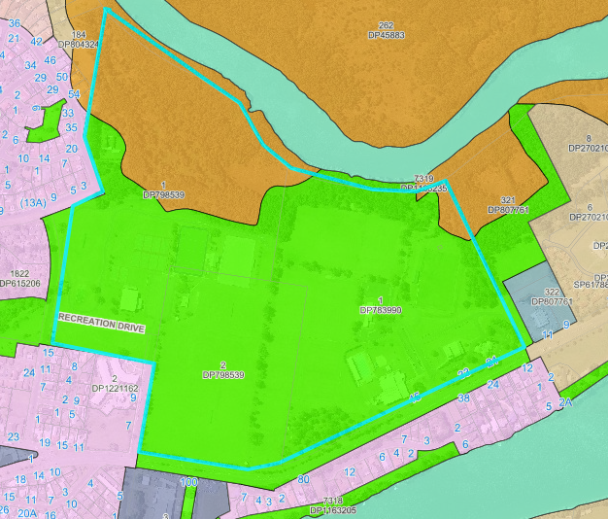
Figure 10: Location map including zoning overlay

The LEP also contains controls relating to development standards, miscellaneous provisions, and local provisions. The controls relevant to the proposal are considered in Table 3 below.

Table 3: Consideration of the LEP controls
Control | Requirement | Proposal
Height of buildings  (cl 4.3) | No height of limitation applies. | The height of the development is in keeping with the existing building and will have a height 14.05m maximum above existing ground levels.
Floor Space Ratio  (cl 4.4) | No floor space limitation applies. | N/A
Heritage conversation  (cl 5.10) | Consideration must be given to the effect of the development on heritage significance of Aboriginal objects or places. | The proposed development is not located within a heritage conservation area or within proximity to any items of heritage.  A basic AHIMS search was conducted and the search reveals no known items of aboriginal cultural heritage located within proximity to the proposed development.
Flood Planning  (cl 5.21) | Consideration must be given to the effect of the flooding on the development. | The site is mapped within the flood planning level under the LEP 2010. The proposed development will have floor levels above the 2100 1% Annual Exceedance Probability flood level.  The development will not have any adverse impact on flood characteristics.
Acid Sulfate Soils  (cl 7.1) | Consideration must be given to the presence of Actual and/or Potential Acid Sulfate Soils and the impact the development may have on such soils. | The development site is site is within the Class 5 mapped area.  Acid sulfate soils are not typically found in Class 5 areas.  The development will not result in the water table being lowered below 1 metre Australian Height Datum on adjacent Class 1, 2, 3 or 4 land.  An acid sulfate soils management plan is not required for the development.
Earthworks  (cl 7.3) | Consideration must be given to impacts arising from earthworks. | Due to the relatively flat topography of the development area, the proposed earthworks are minor in nature. There will be no adverse impact on drainage patterns, soil stability or environmentally sensitive areas.  The earthworks will be supported with suitable erosion and sediment control measures in accordance with Council requirements.

Airspace Operations  (cl 7.4) | The objectives of this clause is to ensure that development does not compromise operations of the Taree airport and to protect the community from undue risk. | The proposed development is located within the Obstacle Limitation Surface (OLS) area with a height limitation of 56m AHD. The proposed development will not increase the height of the existing basketball facility and will remain compliant with the OLS height limitation.  The development will not compromise operations of the Taree Airport. Similarly the development will not be adversely affected by operation of the Taree airport.
Essential services  (cl. 7.11) | Development consent must not be granted unless the consent authority is satisfied the following services are available to the development:  (a) the supply of water,  (b) the supply of electricity,  (c) the disposal and management of sewage,  (d) stormwater drainage or on-site conservation,  (e) suitable vehicular access. | The site has adequate availability of water, sewer, electricity, and telecommunications to service the development.  The development has incorporated appropriate stormwater management.  Suitable vehicle access is provided to the development.  The proposed new elements will be connected to the existing services provided to the basketball facility.

The proposal is considered generally consistent with the LEP.

2.3 Section 4.15 (1)(a)(ii) – Provisions of any proposed instruments
There are no proposed instruments of relevance to the development

2.4 Section 4.15(1)(a)(iii) - Provisions of any Development Control Plan
The Greater Taree Development Control Plan 2010 (DCP 2010) 4 is relevant to the application
The following is a summary of the evaluation of the proposal pursuant to the relevant provisions of the Greater Taree Development Control Plan 2010 (DCP 2010). The aims of the Plan are to ensure good quality, sustainable development outcomes that maintain a high level of environmental amenity. The Plan is designed to allow flexibility in the application of its controls where strict compliance is considered unreasonable or unnecessary provided the relevant objectives of the Plan have been achieved.

Table 4: Consideration of the DCP controls
Control | Requirement | Proposal
Part D Environmental Requirements
D3.1 Earthworks | Building work should be designed to respond to the natural topography of the site wherever possible, minimising the extent of cut and fill. | Due to the relatively flat topography of the development area, the proposed earthworks are minor in nature. There will be no adverse impact on drainage patterns, soil stability or environmentally sensitive areas.
 | All development shall incorporate soil conservation measures to control soil erosion and siltation during and following completion  of development. | Erosion and sediment control measures are to be established during demolition and construction phases of each stage of the proposed development to meet Council and Landcom Blue Book requirements.
  D3.2 Erosion and sediment control requirements
Part E Flooding Requirements
E4.5 Commercial and Industrial | Non-habitable floor levels are to be equal to or greater than FPL3 where possible, or otherwise no lower than FPL1 unless justified by a site specific assessment. | FPL3 is 5.4m AHD (adopted 1% flood level plus 0.5m freeboard).  The existing floor level is 5.29m AHD and it is proposed that the proposed additions be constructed with the same floor level.  The proposed floor will be 390mm above the 1% flood level and is non habitable. The minor variation to floor level is considered acceptable.
E4.5 Commercial and Industrial | All structures to have flood compatible building components below FPL3. | The development can be appropriately conditioned.
E4.5 Commercial and Industrial | Applicant to demonstrate that any structure can withstand the forces of floodwater, debris and buoyancy up to and including FPL3. An engineer’s report must be provided. | The development can be appropriately conditioned.
E4.5 Commercial and Industrial | Engineer’s report required to certify that the development will not increase flood effects elsewhere.
  The proposal is unlikely to create any significant impacts, given the buildings relatively small increase in footprint, and the absence of other buildings.
  The structure is not located within proximity to other structures, and accordingly it is unlikely to have any cumulative effect on the floodplain.
E4.5 Commercial and Industrial | The minimum surface level of open car parking spaces or carports shall be as high as practical, and not below FPL1.
  Parking is as per existing parking arrangements.
E4.5 Commercial and Industrial | Applicant to demonstrate that area is available to store goods above FPL3.
  There is sufficient storage space within the proposed development to store good, including potentially hazardous materials such as cleaning chemicals, above FPL3, internally to the building.
Part G Car Parking and Access
G1.3 Car Parking Requirements for specific land uses | - In the case of a combination of uses, the total requirements for vehicular parking space shall be the sum of the requirements for the various uses, except where it can be demonstrated that the times of real demand for the various uses do not coincide. In those cases the Council will require parking facilities to be provided to serve the peak cumulative demand. | The ‘Taree Regional Recreation Centre’ provides facilities for a number of recreational activities. Facilities that utilise shared parking and access in the vicinity of the development include:  The DCP provides that car parking shall be provided at the rate of 15 spaces per court / filed.  The current uses generate demand for a total of 255 parking spaces.  The proposed development will generate demand for an additional 45 parking spaces, resulting in a cumulative demand of 300 parking spaces.  An existing shared parking area to the east of the development provides parking for 186 vehicles, which services the individual demands of the proposed and adjoining facilities.  The overlap of sporting facilities catered for within the Taree Regional Recreational Facility means that it is unlikely that all facilities will be used at the same time. Most sports stagger times to avoid direct competition with other sports.  Accordingly, it is considered that the 186 shared carparking spaces is sufficient to cater for the demands of the facility.  Notwithstanding the above, there is provisions for 140 street parks immediately adjoining the Centre plus an informal parking area that caters for over 200 vehicles within Recreation Lane.  The availability of this additional parking ensures that the cumulative parking demands of all uses can be met where required.
  - 8 netball courts;
  - 2 outdoor basketball courts
  - 2 indoor basketball courts;
  - 3 hockey fields; and
  - 2 cricket fields.
Part M Site Waste Minimisation and Management
M3.3 Commercial developments and change of use |  | A site waste management plan has been submitted with the application.
  A completed Site Waste Minimisation and Management Plan (SWMMP) shall be prepared and lodged with the demolition application

  - Section 4.15(1)(a)(iiia) – Planning agreements under Section 7.4 of the EP&A Act

There have been no planning agreements entered into and there are no draft planning agreements being proposed for the site.

  - Section 4.15(1)(a)(iv) - Provisions of Regulations

Part 4 Division 1 of the Regulation contains matters that must be taken into consideration by a consent authority in determining a development application. No matters are relevant to the application.

  - Section 4.15(1)(b) - Likely impacts of development

Context, Setting and Design

The proposed development is an addition to an existing basketball facility, sited within a larger recreational precinct. The proposed facility is in keeping with the character of the recreation facility / area and the context and setting is appropriate for the development.

The proposed design is of a height, scale and bulk in keeping with the existing building and suitable for the area. The proposed design, being more contemporary design, will enhance the current dated building and contribute to the aesthetic improvement of the area.

Overall, proposed development is considered to be appropriate given the local context.

Site and Internal Design

The design of the proposed development relates appropriately to the local environmental conditions and the site attributes.

The development relies on a largely vacant unused portion of the site. While several trees will be removed, this will be offset by a vastly improved design of the building and significant deep soli area is retained around the building to accommodate offset planting.

The proposal will require a minor change in alignment of the adjoining criterium track, as well as building buffering by way of a vegetated zone to ensure an appropriate design and safety. The Manning Valley Bike Club have provided their support to the proposed development and realignment of the criterium track.

Overall, the development responds appropriately to the site.

Access and Transport

The proposed upgrade of the basketball stadium includes access and servicing via Bligh Street / Recreation Drive to the existing car park.
The existing road network currently provides access to a variety of recreational uses and adequately services various larger regional sporting events. The proposed development will provide a facility that is also capable of accommodating larger regional events and attracting increased traffic movement to such events.
However, it is not likely that multiple regional events would be held concurrently at the Taree Regional Recreational Centre and the traffic movements for a regional basketball event would be within current operational limits for other regional events.
Accordingly, the proposed development will not give rise to traffic movements exceeding existing capacity and the existing road network is considered adequate to service the development. Notwithstanding, minor adjustments are required to improve safe access including signage and line marking which can be enforced as conditions of consent.
It should be further noted that a Voluntary Planning Agreement is currently in place for development to the south of the subject site and known as Figtrees on the Manning. The VPA provides for upgrading of the Manning River Drive / Bligh Street intersection. While existing access arrangements are considered acceptable the intersection upgrades to be provided as part of the Figtrees on the Manning development will only improve access to the Taree Regional Recreational Centre.
The application also proposes a gravel footpath to the west of the stadium for pedestrian access. The inclusion of a gravel footpath is not supported, and any footpath shall be constructed to Council standards and be of concrete.
Car Parking

The proposed development results in demand for an additional 45 parking spaces. The total parking demand for the completed basketball facility will be 75 parking spaces.

An existing shared carpark is located to the east of the facility and provides 186 parking spaces, which comfortably accommodates the normal operating requirements of the Basketball facility.

This parking area is shared by other recreational facilities and in isolation caters for the individual demands of each facility. Combined, the facilities generate demand for 300 parking spaces, which exceeds the capacity of the shared carpark. This extra demand is accommodated through on street parking, with over 140 spaces available in the vicinity of the facility.

Lot 2 DP597577 to the south of the development site is also available for overflow parking and can accommodate in excess of 200 vehicles. The Greater Taree S94 Contributions Plan includes a $750,000 item to construct additional formalised car parking in this location. The S94 Plan designates the upgrade as item GT21 and is planned to be delivered in the period 2026-31.

As an interim measure to allow this area to be used informally for overflow parking, minor upgrades to access as well as ongoing maintenance should be provided. These include provision for new laybacks as well as measures such as bollards to provide delineation for parking until such time when (if) the area is upgraded as a formal car park. These works can be managed through conditions of consent.

The proposed development will require DDA compliant parking bays as well as amendments to existing shared parking conditions. This includes the requirement for accessible spaces and access to and from the buildings. A site inspection has revealed that the car park surface may not be fit for purpose to facilitate line marking on its own. Conditions have been included to upgrade the asphalt and paths if required to ensure compliant access is achieved for the purpose of issuing an Occupation Certificate.

To accommodate for larger events, a Site operational Management Plan has been developed to manage parking for events where more than 500 persons are expected to be in attendance.

Overall, the parking arrangements are considered suitable for the proposed development.

Natural Hazards

The site is identified as being subject to the hazards of flooding. The 2100 1% Annual Exceedance Probability flood level for the site is 4.9m AHD. The finished floor levels are to be in keeping with existing levels at 5.29m AHD. Accordingly, the floor level will be above the 2100 1% AEP flood level.

As the building is located on flood prone land, it will also be required that the building be constructed to withstand the forces of flood. This can be addressed as a condition of any consent.

To ensure the safety of occupants a site operational management plan has been prepared. While flood free land is available in close proximity to the facility and easily accessible, the management plan provides that the facility is to be closed in the event of a minor or larger flood. While not likely, in the worst case scenario, persons would be required to stay in place and the floor levels being above flood level and having the building constructed to withstand flood forces will assist with safety should such a scenario arise.

It is considered that the development appropriately responds to the natural hazard of flood.

Stormwater

The application was supported with preliminary stormwater design which was deemed inappropriate due to the location of the proposed rain gardens (water treatment systems) and proximity / impact on surrounding infrastructure. Amended plans were requested with a water treatment system to the north in a location confirmed as appropriate by Council’s Asset Manager for Open Spaces and Recreation. Upon receipt of the amended plans, it was established that the functionality of this treatment system was limited to the services located between it and the stadium, and the restrictions that would be met in terms of draining the water via gravity to this point. It was also established that adjustment of the system to achieve gravity fall to this point had the potential to impact acid sulphate soils, the water table as well as be subject to damage in a flood event.

The long-term benefits of having this system constructed failed to outweigh the potential cost associated with ongoing maintenance and it was therefore determined to be deleted.

Further consultation with the Asset Manager of Open Spaces and Recreation identified that there was a need for approximately 10,000L of rainwater re-use (no more) on the site.

Amended plans have been provided to this effect however it is noted that a “bladder system” has been proposed in lieu of an external rainwater tank. This is not acceptable due to the location under the floor of the basketball courts and associated maintenance risk / cost if replacement is required. This can be dealt with by condition through a Section 68 application in addition to the remaining plumbing which has been included as a condition of consent.

On-site detention is not required as the development is at the bottom end of the catchment and any detention would not provide any benefit to the stormwater system in a large rain event.

Noise and Vibration

The proposed development is an extension of an existing basketball facility. The additional courts are not anticipated to give rise to any adverse noise impacts.

Notwithstanding, the operating hours of the development will be restricted to 7am to 10pm only and conditions are proposed to limit noise generated from use of the facility.

Social and Economic Impact

The proposed likely to have positive social and economic benefits for the local area and the broader community.

The development will help promote healthy activities and will enhance an existing recreation facility better catering for regional events and improving local sporting outcomes.

The development will have a positive economic contribution to the locality through the creation of jobs through construction phase, direct employment and with flow on employment multipliers benefitting the local community.

Crime Prevention
The development has been designed to minimise and discourage criminal activity and ensure the safety of customers, staff, and the local community. The proposal has been designed to be consistent with Crime Prevention through Environmental Design (CPTED) principles.

The application was referred to the NSW Police Force for comment. NSW police have raised no objection to the development subject to:

- A Security (Burglar) Alarm System be fitted to the premises;
- Closed Circuit Television cameras and monitors be fitted to the premises; and
- Hours of operation be reviewable should an area of the development at a later time become a particular concern, particularly in the event of significant criminal or anti-social behaviour stemming from the development.

The recommendations of the NSW Police Force are reasonable and can be addressed as conditions of consent

  - Section 4.15(1)(c) - Suitability of the site

The proposal is permitted with consent on the site under the relevant zoning. The proposal is an expansion of an existing recreational facility within a regional recreation precinct.

The proposal has been developed to integrate into the surrounding locality and the site is considered suitable for development as proposed.

  - Section 4.15(1)(d) - Public submissions

The subject development application has been publicly exhibited between 17 February 2022 to 4 April 2022 in accordance with the Environmental Planning and Assessment Act 1979, Environmental Planning and Assessment Regulation 2000 and the MidCoast Council Community Engagement Strategy. As a result of the public exhibition of the application Council received no submissions.

  - Section 4.15(1)(e) – The Public Interest

The proposal is considered to be in the public interest as it will deliver a number of public, social and economic benefits with minimal adverse impact. The land use is appropriate for the location within the recreational area and will enhance an existing basketball facility.

- Other Matters

3.1 Section 7.12 Contributions Plan
The development would require the payment of contributions in accordance with Council’s Section 7.12 Contributions Plan. It is recommended that conditions be imposed on any consent requiring the payment of these contributions prior to the issue of any construction certificate for the development.

4.0 CONCLUSION

After consideration of the development against Section 4.15 of the Environmental Planning and Assessment Act 1979, and the relevant statutory and policy provisions, the proposal is suitable for the site and is in the public interest.

5.0 RECOMMENDATION

It is recommended that Development Application 2021/2110 for the refurbishment and expansion of an existing basketball facility and associated works, at Lot 1 DP 798539, Lot 2 DP 798539 and Lot 1 DP 783990 Manning River Drive Taree, be approved in accordance with the conditions of consent contained in Attachment M.

